# Easier Planning with User-Controlled Scheduling

Planning your project has never been easier. User-controlled scheduling in Microsoft® Project Professional 2010 puts you in control and brings together the flexibility and ease of a tool like Microsoft Excel® 2010 with the power of the Project scheduling engine. Choose the level of detail that is right for each project. Work with summary data initially or drill down into details for more complex phases or projects. This is particularly useful early in planning when details are still unclear or a little fuzzy.

## Step 1: How Long Will It Take?

For duration estimates, enter information directly into the Duration column. For example, type approx. 1 month or 2 weeks assuming no customization, or enter more traditional estimates such as 1 day, 1 week, or 1 month.

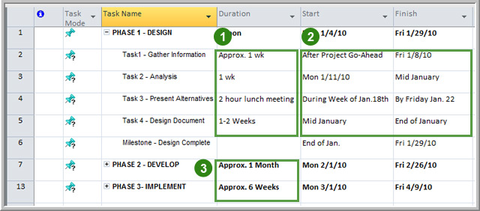

## Step 2: When Will It Start or Finish?

Enter start and finish dates directly in the Start and Finish columns. For example, type 1 week after delivery, 1 month before installation, or Order material 10 days before groundbreaking.

## Step 3: Enter High-Level Phase/Summary Estimates

You also have the option of entering estimates at the summary task or phase level without being affected by rollup calculations of related (indented) detail tasks below the summary or phase level. This makes it easy to do high-level estimating and top-down scheduling.